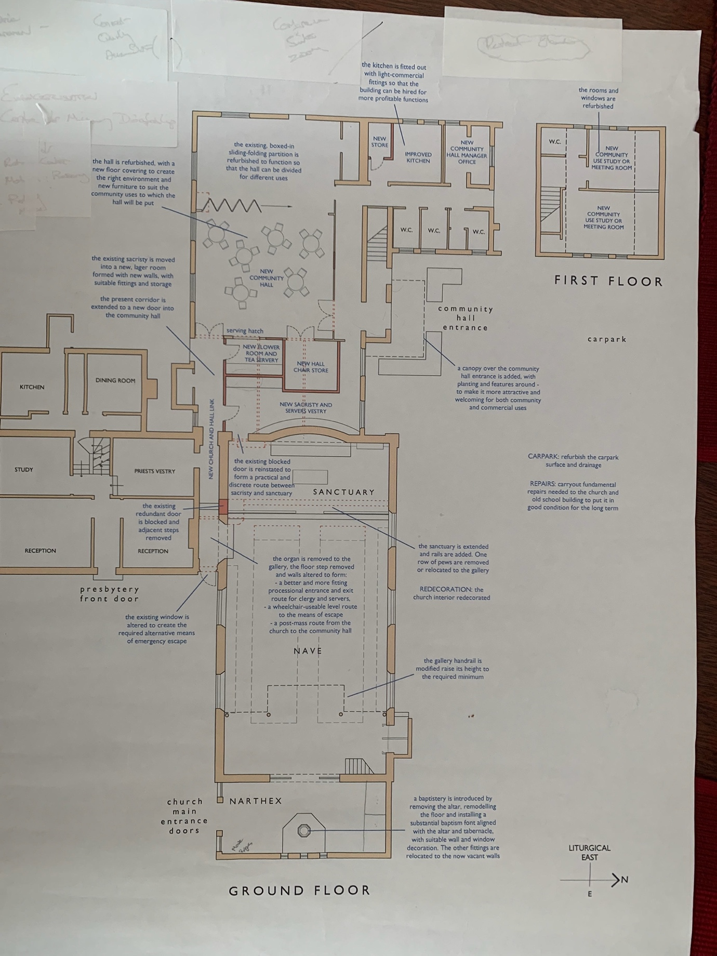

PLANS FOR THE CHURCH

Dear Parishioners,

I attach plans for changes to the Church. There were a number of reasons for this need.

- The need for a new fire exit so that we conform to the new legal requirements.

- The need to tie our buildings together
  - The need to create a parish centre which has become possible now that we have the Old School House.
  - There will be a corridor directly through to the Old School House.

- The need for a larger sacristy

- The need for a parish room independent of the hall.

- The need for a proper baptistery.

- The need for increased confessional size and confidentiality.

- The need for a slightly larger sanctuary.

So the major changes are:
- New fire exit – this will be where the organ is currently positioned and will open out into the car park. The organ will be moved to the balcony.
- A corridor through to the Old School House
- A baptistery in the narthex.
- Double confessional where Our Lady’s altar is.
- A larger sanctuary
- Development of a larger sacristy
- Kitchen hatch and serving area in Old School House.
- An improved entrance to the Old School House.

There are some losses:
- We lose Our Lady’s altar – we shall design an altar that can be used when required; e.g. Altar of repose.
- We shall lose a row of pews on each side. Some capacity can now be increased at the back of the Church. Capacity also will be reduced slightly on the balcony.

We are continuing with designs for the refurbishment of the Church.

